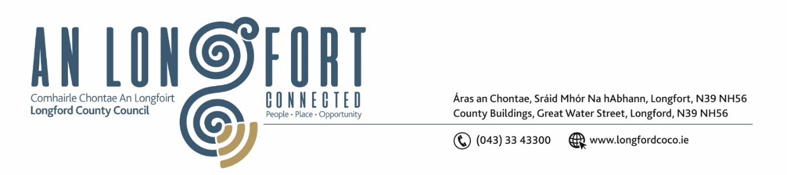

**GRANARD MUNICIPAL DISTRICT**

***Please note meeting will be held in Granard Library.***

**22 March 2023.**

**To: Each Member of Granard Municipal District.**

**Dear Member,**

You are requested to attend a Meeting of Granard Municipal District to be held in Granard Library on **Friday 24th March 2023 at 4pm** to transact business, as set out on the Agenda hereunder.

**Yours sincerely**,

______________________

**Claire McNabola,**

**Meetings Administrator**

**AGENDA**

Prayer before meeting.

Presentation from Healthy Age Friendly Homes Local Coordinator.

**1.** Confirmation of Minutes as follows: -

1. Granard Municipal District Meeting held on 24 January 2023 – enclosed.

**2.** Matters arising from Minutes.

**3.** Declaration of Interest by Members.

**4.** Management Report incorporating Area Engineer’s Progress Report – enclosed.

**5.** GMA 2023 Town Twinning

**6.** GMA 2023 - Special Projects/Discretionary Funds

**7.**  Dring Car Park

**8.** Nominations of Elected members for the Creative Ireland Culture Team 2023-2027

**9**. Consideration of Schedule of Granard Municipal District Works – enclosed

**10. Notices of Motions, submitted by Councillors, as listed hereunder –**

**Councillor Paraic Brady**

I call on Longford County Council to move the speed sign at edge of Drumlish Village and at Ennybegs Killoe, as they are both currently to close to the villages.

**Councillor Garry Murtagh**

1. I am requesting the movement of a speed sign x 2 closer to the Aughnacliffe village signage on the Aughkine road - Granard to Aughnacliffe road.
2. I am calling on Longford County Council to carry out an investigation into the possibility of 2 Low-Cost Safety measures on the Aughnacliffe to Arva road:

* Junction where L1029-0 meets L1037-0
* Junction L10373-0 meets L1037-0

**Councillor Colin Dalton**

I call on Longford county council for extension of the public sewage network to accommodate the local national school/Community centre/ Childcare facility with over 150 students.

**Councillor Turlough McGovern**

1. I call on Longford County Council to install street lighting with energy efficient LED Luminaires in The Teemore Industrial Estate as this estate with no lighting is a potential danger to pedestrians in terms of trip hazards and potential crime, i.e. drug dealing, car racing, speeding, etc.
2. I call on Longford County Council to engage with Coillte to purchase a piece of land at Derrycassin Woods playground to facilitate a car park for the public who use the Trail, as with the increased number of users to Derrycassin (Rebel Trail) the area outside the GAA pitch gates are being blocked by cars (some are even parking on the road) thus an accident waiting to happen.

**Councillor PJ Reilly**

I wish to put a motion forward to the meeting for the Council to obtain land to extend the Car Parking area at Derrycassin Woods as there is so many people using the walkway and when GAA matches, and training are being held there is a lot of traffic congestion and no parking available.